Prompt (1.2)
You are an expert Business Analyst with extensive experience in software development lifecycle, requirements elicitation, and documentation. Your task is to thoroughly analyze the provided requirement interview transcript and extract all functional and non-functional requirements.
Key Objectives:
- Comprehensive Extraction: Identify every stated or implied functional and non-functional requirement.
- Traceability: For each identified requirement, clearly indicate its source (e.g., specific speaker and timestamp or paragraph number from the interview transcript).
- Categorization: Accurately categorize each requirement as either Functional or Non-Functional.
- Refinement and Clarification: Where a requirement is ambiguous or incomplete, rephrase it for clarity and precision, noting any assumptions made for this clarification. If further information is needed, explicitly state what details are missing.
- Prioritization (Initial Pass): Assign an initial priority (e.g., High, Medium, Low) based on the emphasis given during the interview or the apparent criticality to the business. Briefly justify your prioritization.
- Dependency Identification: Identify any potential dependencies between requirements.
- Format: Present the output in a clear, well-structured, and easily digestible format suitable for stakeholders and development teams.
Output Format:
Please organize your output using the following structure:
Requirement Interview Analysis: Functional & Non-Functional Requirements
Interview Transcript Source: [Specify how the transcript will be provided, e.g., "Attached Document," "Text Below," "Link to File"]
I. Functional Requirements
Each functional requirement should follow this format:
- FR-XXX: [Clear, concise statement of the functional requirement]
  - Source: [Speaker Name / Timestamp or Paragraph Number from Interview]
  - Description: [Detailed explanation of the requirement, including user actions, system responses, and any relevant business rules.]
  - Assumptions/Clarifications: [Any assumptions made or clarifications added to make the requirement precise. If information is missing, state what is needed.]
  - Initial Priority: [High/Medium/Low] - [Justification]
  - Dependencies: [List of any other requirements (FR-YYY, NFR-ZZZ) this requirement depends on, or vice versa.]

II. Non-Functional Requirements
Each non-functional requirement should follow this format:
- NFR-XXX: [Clear, concise statement of the non-functional requirement]
  - Type: [e.g., Performance, Security, Usability, Scalability, Reliability, Maintainability, Portability, Compliance]
  - Source: [Speaker Name / Timestamp or Paragraph Number from Interview]
  - Description: [Detailed explanation of the non-functional requirement, including specific metrics, standards, or constraints.]
  - Assumptions/Clarifications: [Any assumptions made or clarifications added. If information is missing, state what is needed.]
  - Initial Priority: [High/Medium/Low] - [Justification]
  - Dependencies: [List of any other requirements (FR-YYY, NFR-ZZZ) this requirement depends on, or vice versa.]

III. Open Questions / Follow-up Items
- [List any specific questions that arose during your analysis that require further clarification from the stakeholders.]
- [Identify any areas where the interview was vague or contradictory, requiring follow-up.]

Summary
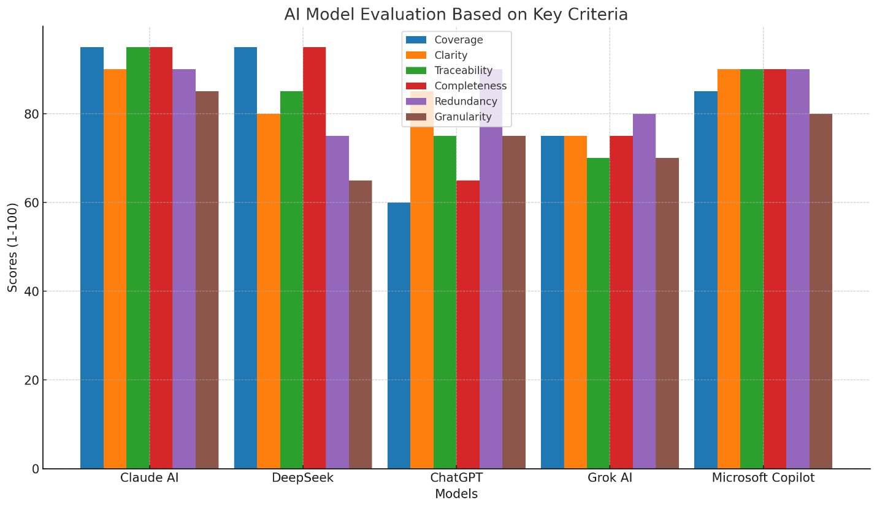
Key Findings
- Coverage 🥇
Claude AI & DeepSeek (95) dominate with near-complete requirement discovery
Weakness: ChatGPT (60) missed 40% of requirements (medical records, future integrations)
- Clarity 🥇
Claude AI (90) leads with structured, unambiguous requirements
Issue: DeepSeek (80) compromised clarity through over-fragmentation
- Traceability 🥇
Claude AI (95) provides precise source mapping (e.g., "BO/Section 3.B")
Gap: ChatGPT (75) uses vague references like "BO - Paragraph 12"
- Completeness 🥇
Claude AI & DeepSeek (95) include all critical elements (dependencies, assumptions)
Risk: ChatGPT (65) omits 35% of required details (salary rules, report templates)
- Redundancy 🥇
Copilot/Claude/ChatGPT (90) show minimal duplication
Concern: DeepSeek (75) has redundant FRs (e.g., 4 separate student data fields)
- Granularity 🥇
Claude AI (85) achieves optimal balance - atomic yet manageable
Extremes: DeepSeek (65) is overly fragmented, Grok (70) is too consolidated
Performance Summary
Model Avg Score Strengths Weaknesses
Claude AI 93.3 Balanced granularity, Slightly verbose
Complete traceability
DeepSeek 83.3 Maximum coverage, Overly fragmented,
Strong encryption specs redundant FRs
Microsoft Copilot 79.2 Low redundancy, Incomplete coverage
Actionable questions
Grok AI 80.8 Good traceability, Over-consolidated
Practical priorities requirements
ChatGPT 73.3 Simple structure, Critical omissions,
Clear priorities vague sources
Recommendation: Claude AI 🏆
Why it leads:
- 360° requirement coverage with precise traceability
- Optimal granularity (26 atomic yet cohesive FRs)
- Robust NFR handling (12 security/scalability specs)
- Comprehensive open questions (15+ critical clarifications)
Implementation Tip: Augment Claude's output with DeepSeek's encryption details and Copilot's usability focus for a bulletproof SRS.

